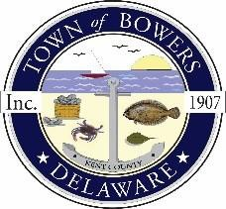

Town of Bowers
3308 Main St. Frederica, DE 19946
(302) 572-9000
Bowersbeach.delaware.gov

AGENDA
Thursday, July 13, 2017
Regular meeting to be brought to order at 7:00 pm

Pledge of Allegiance

Previous Month’s Minutes Approval
Treasurer’s Report

COMMITTEE REPORTS
Parks and Recreation Planning
Streets
Board of Adjustments
Zoning Code Revisions
Code Enforcement Report

OLD BUSINESS
Drainage/Parking Lot Project –
(Anthony Gonzon and Jim Sullivan DNREC)
Beach Replenishment
KC Kent County Crime Watch

NEW BUSINESS
Elections
Upcoming Museum Events

