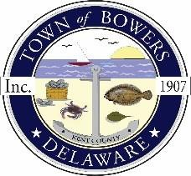

Town of Bowers
3308 Main St. Frederica, DE 19946
(302) 572-9000
Bowersbeach.delaware.gov

AGENDA
Thursday, August 10, 2017
Regular meeting to be brought to order at 7:00 pm

Pledge of Allegiance

Swearing in of reelected council members
Previous Month Minutes Approval
Treasurer’s Report

COMMITTEE REPORTS
Parks and Recreation Planning
Streets
Board of Adjustments
Zoning Code Revisions
Code Enforcement Report

OLD BUSINESS
Drainage/Parking Lot Project
Beach Replenishment
KC Kent County Crime Watch
Elections

NEW BUSINESS
Water Bacteria
Temp drainage solution for N. Bayshore
OPRT Grant Request
Upcoming Museum Events

