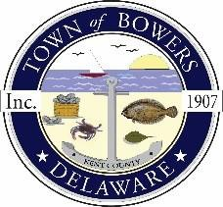

Town of Bowers
3308 Main St. Frederica, DE 19946
(302) 572-9000
Bowersbeach.delaware.gov

AGENDA
Thursday, November 9, 2017
Regular meeting to be brought to order at 7:00 pm

Pledge of Allegiance

Meeting Minutes from last two months Approval
Treasurer’s Report from last two months Approval

COMMITTEE REPORTS
Parks and Recreation Planning
Streets
Board of Adjustments
Zoning Code Revisions
Code Enforcement Report

OLD BUSINESS
Drainage/Parking Lot Project
Beach Replenishment
KC Kent County Crime Watch
N. Bayshore Drainage Progress

NEW BUSINESS
Upcoming Museum Events

