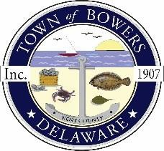

Town ofBowers
3308 Main St. Frederica, DE 19946
(302)572-9000
Bowersbeach.delaware.gov

AGENDA
Thursday, January 18, 2018
Regular meeting to be brought to order at 7:00pm

Pledge of Allegiance

Meeting Minutes Approval
Treasurer’s Report Approval

COMMITTEE REPORTS
Parks and Recreation Planning
Streets
Board of Adjustments
Zoning Code Revisions
Code Enforcement Report
Parking Lot

OLD BUSINESS
Drainage/Parking Lot Project
Beach Replenishment
KC Kent County Crime Watch
N. Bayshore Drainage Progress
Reitmeier Property
Phragmitis Update

NEW BUSINESS
Upcoming Museum Events

