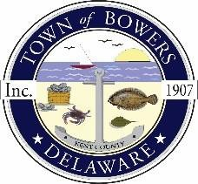

Town ofBowers
3308MainSt. Frederica,DE19946
(302)572-9000
Bowersbeach.delaware.gov

AGENDA
Thursday, December 14, 2017
Regular meeting to be brought to order at 7:00pm

Pledge of Allegiance

Meeting Minutes Approval
Treasurer’s ReportApproval

COMMITTEE REPORTS
Parks and Recreation Planning
Streets
Board of Adjustments
Zoning Code Revisions
Code Enforcement Report
Parking Lot

OLD BUSINESS
Drainage/Parking Lot Project
Beach Replenishment
KC Kent County Crime Watch
N. Bayshore Drainage Progress
Reitmeier Property

NEW BUSINESS
Upcoming Museum Events

