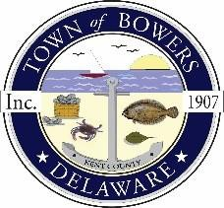

Town ofBowers
3308MainSt. Frederica,DE19946
(302)572-9000
Bowersbeach.delaware.gov

AGENDA
Thursday, February 8, 2018
Regular meeting to be brought to order at 7:00pm

Pledge of Allegiance

Meeting Minutes Approval
December 2017
January 2018

Treasurer’s Report Approval

COMMITTEE REPORTS
Parks and Recreation Planning
Streets
Board of Adjustments
Zoning Code Revisions
Code Enforcement Report
Parking Lot

OLD BUSINESS
Drainage
Discussion and possible action to accept McCrone’s recommendation for awarding the Hubbard Avenue Drainage Improvements project
and to award the contract to the lowest bidder, Zack Excavating, Inc.,
in the amount of $208,566.00.

Parking Lot Project:
Beach Replenishment
KC Kent County Crime Watch

NEW BUSINESS
Upcoming Museum Events

