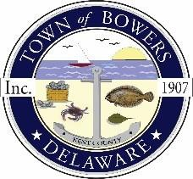

Town of Bowers
3308MainSt. Frederica, DE 19946
(302)572-9000
Bowersbeach.delaware.gov

AGENDA
Thursday, May 10, 2018
Regular meeting to be brought to order at 7:00pm

Pledge of Allegiance
Meeting Minutes Approval
Treasurer’s Report Approval

COMMITTEE REPORTS
Parks and Recreation Planning
Streets
Board of Adjustments
Zoning Code Revisions
Code Enforcement Report
Parking Lot

OLD BUSINESS
Drainage
Parking Lot Project
KC Kent County Crime Watch
Update on Reitmeier Property

NEW BUSINESS
Upcoming Museum Events
Annual Insurance Renewal

