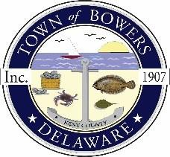

Town ofBowers
3308MainSt. Frederica,DE19946
(302)572-9000
Bowersbeach.delaware.gov

AGENDA
Thursday, June 14, 2018
Regular meeting to be brought to order at 7:00pm

Pledge of Allegiance
Meeting Minutes Approval
Treasurer’s ReportApproval

COMMITTEE REPORTS
Parks and Recreation Planning
Streets
Board of Adjustments
Zoning Code Revisions
Code Enforcement Report
Parking Lot - DNREC Presentation

OLD BUSINESS
Drainage
KC Kent County Crime Watch
Update on Reitmeier Property

NEW BUSINESS
Insurance Renewal
Upcoming Museum Events

