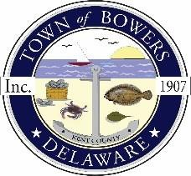

Town of Bowers
3308 Main St., Frederica, DE 19946
(302)572-9000
Bowersbeach.delaware.gov

AGENDA
Thursday, October 11, 2018
Regular meeting to be brought to order at 7:00pm

Pledge of Allegiance
Meeting Minutes Approval
Treasurer’s Report Approval

COMMITTEE REPORTS
Parks and Recreation
Animal Control
Planning
Streets
Board of Adjustments
Zoning Code Revisions
Code Enforcement Report
Parking Lot

OLD BUSINESS
Drainage
KC Kent County Crime Watch

NEW BUSINESS
Upcoming Museum Events

