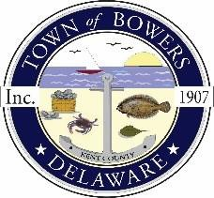

Town of Bowers
3308 Main St., Frederica,DE 19946
(302)572-9000
Bowersbeach.delaware.gov

AGENDA
Thursday, September 13, 2018
Regular meeting to be brought to order at 7:00pm

Assignment of positions for council members

Pledge of Allegiance
Meeting Minutes Approval for July and August
Treasurer’s Report Approval
EXECUTIVE SESSION CONCERNING SALES OR LEASES OF REAL PROPERTY

COMMITTEE REPORTS
Parks and Recreation Planning
Streets
Board of Adjustments
Zoning Code Revisions
Code Enforcement Report
Parking Lot

OLD BUSINESS
Drainage
KC Kent County Crime Watch
Update on Reitmeier Property

NEW BUSINESS
DNREC Officer for Discussion on the Burning Ban and Beach Fires
Upcoming Museum Events

