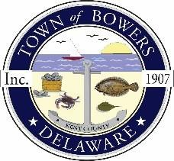

Town ofBowers
3308Main St., Frederica, DE19946
(302)572-9000
Bowersbeach.delaware.gov

AGENDA
Thursday, December 13, 2018
Regular meeting to be brought to order at 7:00pm

Pledge of Allegiance
Meeting Minutes Approval for November
Treasurer’s ReportApproval for November

COMMITTEE REPORTS
Parks and Recreation Planning
Streets
Board of Adjustments
Zoning Code Revisions
Code Enforcement Report
Parking Lot

OLD BUSINESS
Drainage – Approval of Change Orders
and Change Order Resolution
OPRT Grant
Parking Lot Grant Proposal
KC Kent County Crime Watch

NEW BUSINESS
Upcoming Museum Events

