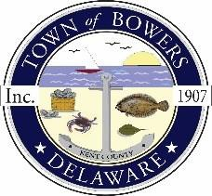

Town ofBowers
3308Main St., Frederica, DE19946
(302)572-9000
Bowersbeach.delaware.gov

AGENDA
Thursday, January 10, 2019
Regular meeting to be brought to order at 7:00pm

Pledge of Allegiance
Meeting Minutes Approval for December
Treasurer’s Report Approval for December

COMMITTEE REPORTS
Parks and Recreation Planning
Streets
Board of Adjustments
Zoning Code Revisions
Code Enforcement Report
Parking Lot

OLD BUSINESS
Drainage
KC Kent County Crime Watch

NEW BUSINESS
Upcoming Museum Events

