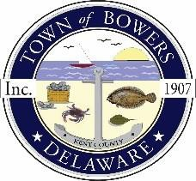

Town of Bowers
3308 Main St., Frederica ,DE 19946
(302)572-9000
Bowersbeach.delaware.gov

AGENDA
Thursday, November 8, 2018
Regular meeting to be brought to order at 7:00pm

Pledge of Allegiance
Meeting Minutes Approval for September
Treasurer’s Report Approval for September

COMMITTEE REPORTS
Parks and Recreation Planning
Streets and Snow removal
Board of Adjustments
Zoning Code Revisions
Code Enforcement Report
Parking Lot

OLD BUSINESS
Drainage
Parking Lot Grant Proposal
KC Kent County Crime Watch

NEW BUSINESS
Investment CD Renewal
BFC Halloween Party Donation
Upcoming Museum Events

