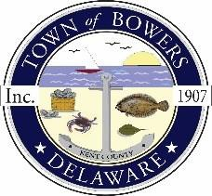

Town of Bowers
3308Main St., Frederica, DE19946
(302)572-9000
Bowersbeach.delaware.gov

AGENDA
Thursday, March 14, 2019
Regular meeting to be brought to order at 7:00pm

Pledge of Allegiance

Meeting Minutes Approval for February
Treasurer’s Report Approval for Dec 2018, Jan 2019, and Feb 2019

COMMITTEE REPORTS
Parks and Recreation Planning
Streets
Board of Adjustments
Zoning Code Revisions
Code Enforcement Report
Parking Lot (Anthony will be in attendance to give an update on the plans)

OLD BUSINESS
Drainage
State Law for Dogs on Beach May to September
KC Kent County Crime Watch

NEW BUSINESS
Upcoming Museum Events

