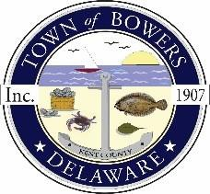

Town of Bowers
3308 Main St., Frederica, DE19946
(302)572-9000
Bowersbeach.delaware.gov

AGENDA
Friday, June 28, 2019
Regular meeting to be brought to order at 4:00pm

Pledge of Allegiance

Meeting Minutes Approval for May 2019
Treasurer’s Report Approval for May 2019

COMMITTEE REPORTS
Parks and Recreation Planning
Streets
Board of Adjustments
Zoning Code Revisions
*Rezoning of lots between N. Flack Avenue and N. Bayshore Drive*
Code Enforcement Report
Parking Lot

OLD BUSINESS
Drainage
KC Kent County Crime Watch

NEW BUSINESS
Moving Town Hall to a new location
Comprehensive Plan:
Discussion and potential action to initiate comprehensive plan amendment and rezoning process for property situated on N. Bayshore and known as lots 22-25, 32, and an undesignated 2-acre parcel, further identified as tax map parcel numbers 8-01-11513-01-0300-000 and 8-01-11513-01-0200-000, in order to rezone said parcels for residential purposes.
Upcoming Elections
Upcoming Museum Events

