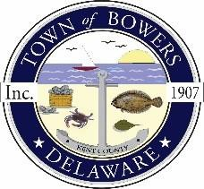

Town of Bowers
3308 Main St., Frederica, DE19946
(302)572-9000
Bowersbeach.delaware.gov

AGENDA
Thursday, August 8, 2019
Regular meeting to be brought to order at 7:00pm
Swearing in of Council Members
Selecting Treasurer

Pledge of Allegiance

Meeting Minutes Approval for June and July 2019
Treasurer’s Report Approval for July 2019

COMMITTEE REPORTS
Parks and Recreation Planning
Streets
Board of Adjustments
Zoning Code Revisions
Code Enforcement – Partition of Hionis Property
(40 N. Bayshore Drive)
Parking Lot

OLD BUSINESS
Drainage
KC Kent County Crime Watch
(Ricky Maddox, President KC Crime Watch Attending)
Moving Town Hall

NEW BUSINESS
Upcoming Museum Events

