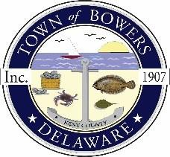

Town of Bowers
3308Main St., Frederica, DE19946
(302)572-9000
Bowersbeach.delaware.gov

AGENDA
Thursday, May 09, 2019
Regular meeting to be brought to order at 7:00pm

Pledge of Allegiance

Meeting Minutes Approval for April 2019
Treasurer’s Report Approval for April 2019

COMMITTEE REPORTS
Parks and Recreation Planning
Streets
Board of Adjustments
Zoning Code Revisions
Code Enforcement Report
Parking Lot

OLD BUSINESS
Drainage
KC Kent County Crime Watch

NEW BUSINESS
Upcoming Museum Events

