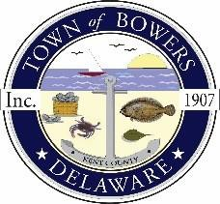

Town of Bowers
3308 Main St., Frederica, DE19946
(302)572-9000
Bowersbeach.delaware.gov

AGENDA
Thursday, September 12, 2019
Regular meeting to be brought to order at 7:00pm

Pledge of Allegiance

Meeting Minutes Approval for August 2019
Treasurer’s Report Approval for August 2019

Discussion and Possible Action on
AN ORDINANCE PROPOSING TO AMEND THE TOWN OF BOWERS COMPREHENSIVE PLAN
TO REVISE THE DESIGNATION OF TAX MAP PARCEL NOS.
8-01-11513-01-0200-000 AND 8-01-11513-01-0300-000
ON THE FUTURE LAND USE MAP FROM CONSERVATION/AGRICULTURAL TO RESIDENTIAL

COMMITTEE REPORTS
Parks and Recreation Planning
Streets
Board of Adjustments
Zoning Code Revisions
Code Enforcement
45 N. Bayshore Drive Partition
56 N. Flack Partition
Parking Lot

OLD BUSINESS
KC Kent County Crime Watch
Moving Town Hall

NEW BUSINESS
Upcoming Museum Events

