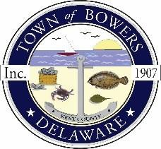

Town of Bowers
3308Main St., Frederica, DE19946
(302)572-9000
Bowersbeach.delaware.gov

AGENDA
Thursday, October 10, 2019
Regular meeting to be brought to order at 7:00pm

Pledge of Allegiance

Meeting Minutes Approval for August and September 2019
Treasurer’s Report Approval for August 2019

DSP Officer Heather answers questions concerning fireworks and
other issues that the town residents may have

COMMITTEE REPORTS
Parks and Recreation Planning
Streets
Board of Adjustments

Zoning Code Revisions
Discussion and possible action on An Ordinance Proposing to Rezone Tax Map Parcel Nos. 8-01-11513-01-0200-000 and 8-01-11513-01-0300-000 from Conservation/Agricultural to R-1 Residential.

Code Enforcement
Parking Lot

OLD BUSINESS
KC Kent County Crime Watch
Town Hall Move

NEW BUSINESS
Upcoming Museum Events

