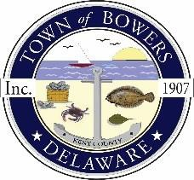
Town of Bowers
3308Main St., Frederica, DE19946
(302)572-9000
Bowersbeach.delaware.gov

AGENDA
Thursday, November 14, 2019
Regular meeting to be brought to order at 7:00pm

Pledge of Allegiance

Meeting Minutes Approval for October 2019
Treasurer’s Report Approval for October 2019

COMMITTEE REPORTS
Parks and Recreation Planning

Streets
(Williams Avenue – cracks in blacktop need to be fixed)

Board of Adjustments
Zoning Code Revisions
Code Enforcement
Parking Lot

OLD BUSINESS
KC Kent County Crime Watch

NEW BUSINESS
Donation to help BFC with Halloween Party
Upcoming Museum Events

