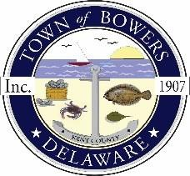
Town of Bowers
3357 Main St., Frederica, DE 19946
(302)572-9000
Bowersbeach.delaware.gov

AGENDA
Wednesday, December 18, 2019
Special meeting to be brought to order at 6:00pm

Pledge of Allegiance

- Public Hearing to obtain public comments on a proposed
amendment to the Bowers Comprehensive Plan Future Land Use Map
and the Bowers Zoning Map to rezone tax map parcel numbers 8-01-11513-01-0200-00001
and 8-01-11513-01-0300-00001, owned by DelMarsh, LLC, from Conservation/Agricultural (C/A)
to Residential (R-1).

- Discussion and possible action on:
  - Ord. No. 01-019, An Ordinance Proposing to Amend the Town of Bowers
Comprehensive Plan to Revise the Designation of Tax Map Parcel Nos.
8-01-11513-01-0200-00001 and 8-01-11513-01-0300-00001 on the Future
Land Use Map from Conservation/Agricultural to Residential
  - Ord. No. 02-019, An Ordinance Proposing to Rezone Tax Map Parcel Nos.
8-01-11513-01-0200-00001 and 8-01-11513-01-0300-00001 from Conservation/
Agricultural to R-1 Residential

