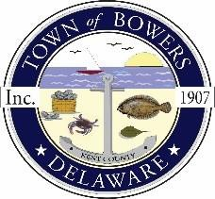
Town of Bowers
3357 Main St., Frederica, DE 19946
(302)572-9000
Bowersbeach.delaware.gov

AGENDA
Thursday, December 12, 2019
Regular meeting to be brought to order at 7:00pm

Pledge of Allegiance

Meeting Minutes Approval for November 2019
Treasurer’s Report Approval for November 2019

COMMITTEE REPORTS
Parks and Recreation Planning
Streets - Snow Removal Proposal
Board of Adjustments
Zoning Code Revisions
Code Enforcement
Parking Lot

OLD BUSINESS
KC Kent County Crime Watch

NEW BUSINESS
Upcoming Museum Events

