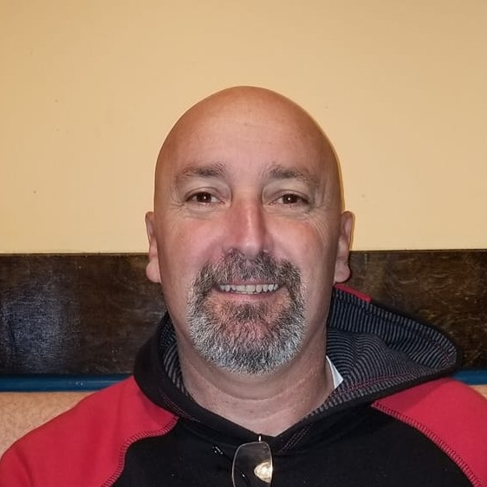

Hi, my name is Wayne Irons, Jr.and I am running for a council seat for the Town of Bowers.
I am a 53-year-old single 3 year resident with ties in our fishing industry from birth until 33 years old.
My Father's family were long time Bowers residents. Charlie Irons and Annabelle Irons were my Grandparents
and I have many cousins including the Banks family, Sleucer family and Potter family. Faulkner’s Pier was a
Head boat and Charter boat business started by my maternal Grandparents, William and Edna Faulkner, in 1930.
My parents, Wayne and Maureen Irons and my Aunt and Uncle, Bill and Phyllis Moore, took over operations in 1975
as my Grandparents retired staying close by.

I graduated from Milford High School in 1985 and went into the United States Marine Corp in January of 1986.
From Bootcamp in Parris Island, SC to Camp Lejeune, NC and 3 tours in Okinawa, Japan- I served proudly as Crew
Chief of an Amphibious Assault Vehicle, MOS 1833 Am tracker. I went on a South American float, Unitas, through
the Panama Canal down the west side and back up the east side of South America and later volunteered duty in
Desert Storm from 1990-1991. I was honorably discharged January 11th1992 .I decided not to re-enlist and returned
to work on the boats in 1992. I married and had my 2 children, Devin and Brandon Irons.

I started working for my current employer IGT, International Gaming Technology, in 1998 and have been there almost
23 years. I enjoy spending time with my children and family and am also an avid hunter, fisherman, boats man and crabber
throughout the corresponding seasons. My vast experience with people and also being a lifelong Bowers Beacher would qualify
me to serve as Vice Mayor and bring fresh ideas to implement and make this lovely beach town and fishing village an even better
place to call home.

