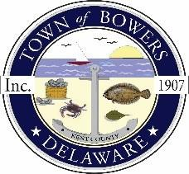
Town of Bowers
3357 Main St., Frederica, DE19946
(302)572-9000
Bowersbeach.delaware.gov

AGENDA
Thursday, July 16, 2020
Board of Elections meeting to be brought to order at 4:30 pm

The Board of Elections for 2020 will meet to discuss:
RULES
RESPONSIBLITIES
PROCEDURES

