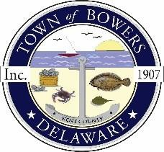
Town of Bowers
3357 Main St., Frederica, DE19946
(302)572-9000
Bowersbeach.delaware.gov

AGENDA
Thursday, December 10, 2020
Regular meeting to be brought to order at 7:00pm
Join Zoom Meeting
Meeting ID: 891 7258 9388
Passcode: 783779

Pledge of Allegiance

MINUTES AND REPORTS
Meeting Minutes Approval for November 2020
Treasurer’s Report Approval for November 2020

COMMITTEE REPORTS
Parking Lot
Watermen’s Park
Parks and Recreation
Planning/Zoning Code Revisions
Streets
Code Enforcement:
Board of Adjustments

OLD BUSINESS
Drainage on North Bayshore Drive

NEW BUSINESS
CARES eligible purchases discussion and possible
Upcoming Museum Events

RESIDENT CONCERNS/TOPICS
None were submitted for this month

