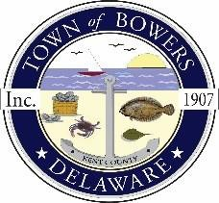
Town of Bowers
3357 Main St., Frederica, DE 19946
(302)572-9000
Bowersbeach.delaware.gov

AGENDA
Thursday, February 11, 2021
Regular meeting to be brought to order at 7:00pm

Join Zoom Meeting
Meeting ID: 889 6199 2285
Passcode: 470503

Pledge of Allegiance
MINUTES AND REPORTS
Meeting Minutes Approval for January 2021
Treasurer’s Report Approval for January 2021

COMMITTEE REPORTS
Parking Lot
Watermen’s Park
Parks and Recreation
Planning/Zoning Code Revisions
Streets (Grass Cutting Proposals)
Code Enforcement:
Board of Adjustments

OLD BUSINESS
Drainage on North Bayshore Drive
Car Charging Stations
Town dock and south end of Hubbard

NEW BUSINESS
Upcoming Museum Events

RESIDENT CONCERNS/TOPICS
Urban & Community Forestry Grant

