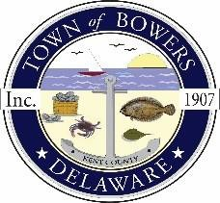
Town of Bowers
3357 Main St., Frederica, DE19946
(302)572-9000
Bowersbeach.delaware.gov

AGENDA
Thursday, March 11, 2021
Regular meeting to be brought to order at 7:00pm

Join Zoom Meeting
Meeting ID: 878 5333 1534
Passcode: 235103

Pledge of Allegiance
MINUTES AND REPORTS
Meeting Minutes Approval for January 2021
Meeting Minutes Approval for February 2021
Treasurer’s ReportApproval for January 2021

COMMITTEE REPORTS
Parking Lot
Watermen’s Park
Parks and Recreation
Planning/Zoning Code Revisions
Streets
Code Enforcement:
Board of Adjustments

OLD BUSINESS
Drainage on North Bayshore Drive
Town dock and south end of Hubbard
Urban & Community Forestry Grant

NEW BUSINESS
Waste / Recycle Contract
Budget Review and Planning
Bus Shelter
Upcoming Museum Events

RESIDENT CONCERNS/TOPICS
Cell Phone Coverage

Reminder: please notify Ada Puzzo or Shirley Pennington by the first Thursday of every month if you have a concern or topic you would like to address at the next Town Meeting

