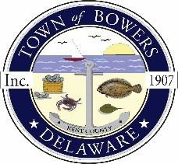
Town of Bowers
3357 Main St., Frederica, DE19946
(302)572-9000
Bowersbeach.delaware.gov

AGENDA
Monday, April 19, 2021
Council Working Session to be brought to order at 6:00pm

Join Zoom Meeting

Meeting ID: 893 4252 7076
Passcode: 705432

