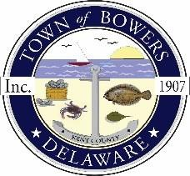
Town ofBowers
3357 Main St., Frederica, DE19946
(302)572-9000
Bowersbeach.delaware.gov

AGENDA
Thursday, April 8, 2021
Regular meeting to be brought to order at 7:00pm

Join Zoom Meeting
Meeting ID: 841 6271 4365
Passcode: 209375
Pledge of Allegiance
MINUTES AND REPORTS
Meeting Minutes Approval for February 2021
Meeting Minutes Approval for March 2021
Treasurer’s ReportApproval for March 2021

COMMITTEE REPORTS
Parking Lot
Watermen’s Park
Parks and Recreation
Planning/Zoning Code Revisions
Streets
Code Enforcement:
Board of Adjustments

OLD BUSINESS
Drainage on North Bayshore Drive
Town dock and south end of Hubbard
Urban & Community Forestry Grant
Town Budget

NEW BUSINESS
Upcoming Museum Events
Channel Dredging and Rock Jetty

RESIDENT CONCERNS/TOPICS

