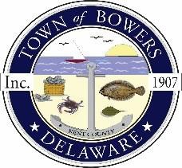
Town of Bowers
3357 Main St., Frederica, DE19946
(302)572-9000
Bowersbeach.delaware.gov

AGENDA
Monday, May 17, 2021
Council Working Session to be brought to order at 6:00pm

Join Zoom Meeting

Meeting ID: 884 9284 1901
Passcode: 623460

