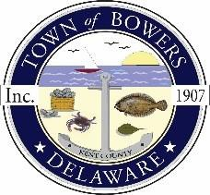
Town ofBowers
3357 Main St., Frederica, DE 19946
(302)572-9000
Bowersbeach.delaware.gov

AGENDA
Thursday, May 13, 2021
Regular meeting to be brought to order at 7:00pm

Join Zoom Meeting
Meeting ID: 813 1142 0812
Passcode: 772060

Pledge of Allegiance
MINUTES AND REPORTS
Meeting Minutes Approval for April 2021
Treasurer’s ReportApproval for April 2021

COMMITTEE REPORTS
Parking Lot
Watermen’s Park
Parks and Recreation
Planning/Zoning Code Revisions
Streets
Code Enforcement:
Board of Adjustments

DISCUSSION AND POSSIBLE ACTION
Discussion and possible action to approve
R-2021-05-21-01
RESOLUTION ADOPTING REVISIONS TO THE DECEMBER 14, 2004
ALL HAZARD MITIGATION PLAN FOR
THE TOWN OF BOWERS AND KENT COUNTY

OLD BUSINESS
Drainage on North Bayshore Drive
Dredging

NEW BUSINESS
Upcoming Museum Events

RESIDENT CONCERNS/TOPICS
Reminder: please notify Ada Puzzo or Shirley Pennington by the first Thursday
of every month if you have a concern or topic you would
like to address at the next Town Meeting

