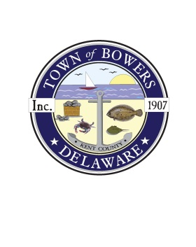
PUBLIC NOTICE

SOLICITATION OF CANDIDATES
TOWN OF BOWERS

The Town of Bowers is seeking candidates for two open seats on the Town Council. The term of office for each of these positions is two years and any eligible citizen may file and run for these offices.

The Election for these positions is currently scheduled for:

Saturday, August 7, 20201 from 2:00pm until 7:00pm at the Bowers Town Hall.

Positions Open:
Two Council Seats with a term of two years.

Eligibility Requirements:
- 18 years of age or older by the date of the election – Saturday, August 7, 2021.
- Must be a current resident of the Town of Bowers and expect to remain a resident for the duration of the term of office.

Procedure for Filing:
Persons wishing to file as a candidate for these positions must submit Bowers Municipal Election Candidate Filing Form
(Available at:http://bowersbeach.delaware.gov/municipal-elections/- or by requesting a form from the Town Council Secretary.)

For further information or forms email secretary@bowersde.gov
Or call 302-242-8148

FILING DEADLINE: Friday, June 25, 2020 – 5:00pm.

