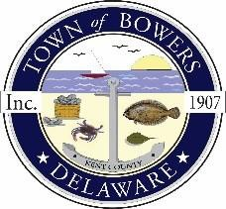
Town of Bowers
3357 Main St., Frederica, DE19946
(302)572-9000
Bowersbeach.delaware.gov

AGENDA
Thursday, June 24, 2021
Regular meeting to be brought to order at 7:00pm
Join Zoom Meeting
Meeting ID: 896 1742 0697
Passcode: 866584

Pledge of Allegiance
MINUTES AND REPORTS
Meeting Minutes Approval for April 2021
Meeting Minutes Approval for May 2021
Treasurer’s ReportApproval for May 2021
COMMITTEE REPORTS
Parking Lot
Watermen’s Park
Parks and Recreation
Planning/Zoning Code Revisions
Streets
Code Enforcement:
Board of Adjustments

OLD BUSINESS
Drainage on North Bayshore Drive
Dredging

NEW BUSINESS
Elections
Budget
ARPA Funds
Mayor’s Comments
Upcoming Museum Events

RESIDENT CONCERNS/TOPICS
Dogs on the Beach
Wyatt Avenue vs Wyatt Street
No Outlet sign needed on Wyatt

Reminder: please notify Ada Puzzo or Shirley Pennington by the first Thursday
of every month if you have a concern or topic you would
like to address at the next Town Meeting

