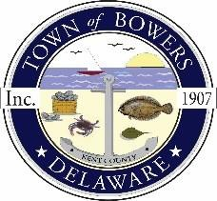
Town ofBowers
3357 Main St., Frederica, DE19946
(302)572-9000
Bowersbeach.delaware.gov

AGENDA
Thursday, August 19, 2021
Regular meeting to be brought to order at 7:00pm
Join Zoom Meeting
Meeting ID: 860 6388 2918
Passcode: 240158

Pledge of Allegiance
MINUTES AND REPORTS
Meeting Minutes Approval for July2021
Treasurer’s ReportApproval for July 2021
DISCUSSION AND POSSIBLE ACTION
Discussion and possible action to approve the 2021 Tree Planting Grant Contract
from the Forest Service’s Urban Forestry Program grant program, totaling $3,500 (Contract #TP 2021-21).

COMMITTEE REPORTS
Parking Lot
Watermen’s Park
Parks and Recreation
Planning/Zoning Code Revisions
Streets
Code Enforcement
Board of Adjustments

OLD BUSINESS
Drainage on North Bayshore Drive
Dredging / Jetty

NEW BUSINESS
Dover/KC Metropolitan Planning Origination (MPO), FY22 Unified Planning Work Program (UPWP)
Study of improvements along Bowers Road (Rt. 18) and Main Street (town road) for bicycle and pedestrian facilities

Upcoming Museum Events

RESIDENT CONCERNS/TOPICS

Reminder: please notify Ada Puzzo or Shirley Pennington by the first Thursday of every month
if you have a concern or topic you wouldlike to address at the next Town Meeting

