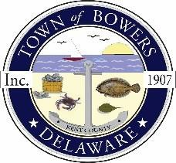
Town of Bowers
3357 Main St., Frederica, DE19946
(302)572-9000
Bowersbeach.delaware.gov

AGENDA

Thursday, August 31, 2021
Drainage Planning meeting to be brought to order at 6:30pm

Join Zoom Meeting

Meeting ID: 857 1845 8612
Passcode: 018266

