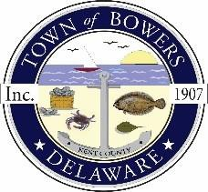
Town of Bowers
3357 Main St., Frederica, DE 19946
(302)572-9000
Bowersbeach.delaware.gov

AGENDA
Thursday, September 9, 2021
Regular meeting to be brought to order at 7:00pm
Join Zoom Meeting
Meeting ID: 845 2795 7997
Passcode: 394866

Pledge of Allegiance
MINUTES AND REPORTS
Meeting Minutes Approval for July 2021 and August 2021
Treasurer’s ReportApproval for August 2021

COMMITTEE REPORTS
Parking Lot
Watermen’s Park
Parks and Recreation
Planning/Zoning Code Revisions
Streets
Code Enforcement
Board of Adjustments

OLD BUSINESS
Dredging / Jetty
DISCUSSION AND POSSIBLE ACTION
Discussion and possible action to select a drainage improvement option for North Bayshore and North Flack.

NEW BUSINESS
Upcoming Museum Events

RESIDENT CONCERNS/TOPICS
Offensive Flag and Sense of Town

Reminder: please notify Ada Puzzo or Shirley Pennington by the first Thursday of every month
if you have a concern or topic you wouldlike to address at the next Town Meeting

