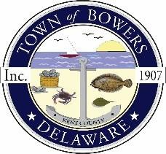
Town of Bowers
3357 Main St., Frederica, DE19946
(302)572-9000
Bowersbeach.delaware.gov

AGENDA
Monday, August 16, 2021
Council Working Session to be brought to order at 6:00pm

Join Zoom Meeting

Meeting ID:
Passcode:

