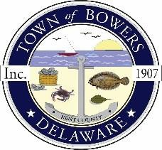

Town of Bowers
3357 Main St., Frederica, DE19946
(302)572-9000
Bowersbeach.delaware.gov

AGENDA
Thursday, October 14, 2021
Regular meeting to be brought to order at 7:00pm
Join Zoom Meeting
Meeting ID: 831 7982 2709
Passcode: 029288

Pledge of Allegiance
MINUTES AND REPORTS
Meeting Minutes Approval for July2021, August 2021, and September 2021
Treasurer’s Report Approval for September 2021

COMMITTEE REPORTS
Parking Lot
Watermen’s Park
Parks and Recreation
Planning/Zoning Code Revisions: Partition of lot of 0.23 acres of land
situated between N Flack Ave. and N Bayshore Dr., tax mapparcel 8-01-11513-01-3902-00001,
into two lots approximately 50’ X 100’ in size
Streets
Code Enforcement
Board of Adjustments
OLD BUSINESS
Dredging / Jetty
Dover/KC MPO:Study of improvements along Bowers Road (Rt. 18)
and Main Street (town road) for bicycle and pedestrian facilities
Drainage
DISCUSSION AND POSSIBLE ACTION
Discussion and possible action to modify the FY22 Budget
NEW BUSINESS
Upcoming Museum Events

RESIDENT CONCERNS/TOPICS

Reminder: please notify Ada Puzzo or Shirley Pennington by the first Thursday of every month
if you have a concern or topic you would like to address at the next Town Meeting

