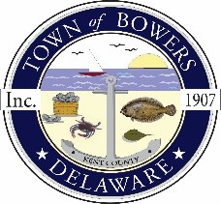

The Town of Bowers
3357 Main St.
Frederica, DE 19946
(302) 572-9000
bowersbeach.delaware.gov
TOWN COUNCIL WORKGROUP MINUTES
The meeting was called to order at 6:00pm on July 18, 2022 byMayor Ada Puzzo. Council members present:Shirley Pennington, Wayne Irons, Marty Manning, and Bob McDevitt.

Pledge was recited in unison.

DISCUSSION BY COUNCIL

Mayor Ada discussed the dredging and said that we have support from Kent and New Castle County legislators. There will be a public announcement on Friday and it should be a notice to proceed.
Lt. Col from Army Corp of Engineers reached out to Aaron Warren, Chief of Bowers Fire Company and he, in turn, called Ada. We are hoping to have some visitors on Friday to see why the dredging is so important and it should be low tide around 11:30 am that day which would be perfect conditions for them to see.

Bob McDevitt discussed the signage and said that larger signs will require two posts. We agreed to start with the kiosks and put information there. Scott Eatough has volunteered to help with the signage.

Marty Manning had no items to discuss.

Shirley Pennington had no items to discuss

Wayne Irons had no items to discuss

NEXT MEETING AND ADJOURNMENT

There being no further business, a motion was made and seconded to adjourn the meeting. Motion Carried.
The next townworking group meeting will be held on July 18, 2022 starting at 6:00 pm at Town Hall. Town residents may join via zoom

Respectfully submitted,

Shirley A. Pennington
Secretary

