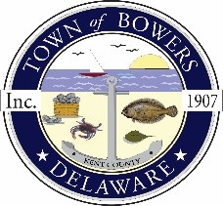

The Town of Bowers
3357 Main St.
Frederica, DE 19946
(302) 572-9000
bowersbeach.delaware.gov
TOWN COUNCIL WORKGROUP MINUTES
The meeting was called to order at 6:14 pm on June 18, 2022 byMayor Ada Puzzo. Council members present:Shirley Pennington, Wayne Irons, Marty Manning, and Bob McDevitt.
Howie Houseknect attended on Zoom.

Pledge was recited in unison.

DISCUSSION BY COUNCIL

Bob MecDevitt discussed the planning committees revision to the code.

Marty Manning had no items to discuss.

Shirley Pennington discussed the upcoming elections on August 6, 2022. We are still waiting to see who will be running for town council and if there will be an election.

Mayor Ada had no items to discuss.

Wayne Irons discussed the police presence within the town and the residents concern. DSP will be here on Friday for a few hours. He will talk with the Mayor of Frederica to discuss their police force and see if we can come up with ideas for Bowers.

NEXT MEETING AND ADJOURNMENT

There being no further business, a motion was made and seconded to adjourn the meeting. Motion Carried.
The next townworking group meeting will be held on July 18, 2022 starting at 6:00 pm at Town Hall. Town residents may join via zoom

Respectfully submitted,

Shirley A. Pennington
Secretary

