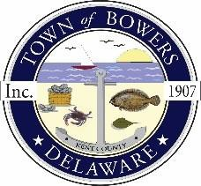

Town of Bowers
3357 Main St., Frederica, DE19946
(302)572-9000
Bowersbeach.delaware.gov

AGENDA
Thursday, July 14, 2022
Regular meeting to be brought to order at 7:00pm
Join Zoom Meeting

Pledge of Allegiance
MINUTES AND REPORTS
Meeting Minutes Approval for June 2022
Treasurer’s Report Approval for June 2022
COMMITTEE REPORTS
Parking Lot
Watermen’s Park
Parks and Recreation
Planning/Zoning Code Revisions
Public Water
Streets
Code Enforcement
Board of Adjustments
OLD BUSINESS
Dredging / Jetty
Drainage
Town Elections

NEW BUSINESS
Upcoming Museum Events

RESIDENT CONCERNS/TOPICS
COUNCIL COMMENTS

Reminder: please notify Ada Puzzo or Shirley Pennington by the first Thursday of every month
if you have a concern or topic you would like to address at the next Town Meeting

