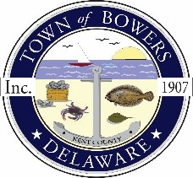

The Town of Bowers
3357 Main St.
Frederica, DE 19946
(302) 572-9000
bowersbeach.delaware.gov
Working session minutes

The meeting was called to order at 7:00 pm on November 20 2023 by Mayor Ada Puzzo. Council members present: Marty Manning and Wayne Irons Chris Telles.
The Pledge of Allegiance was recited in unison

Wayne Irons
Wayne requested a check to reimburse Tink for trash bags and tarps in the amount of $93.00
Wayne got an estimate of $25,000.00 for two the mini splits with four heads from Massina HVAC.
Wayne will look into a better price from other vendors.

Bob McDevitt
Not in attendance

Marty Manning
Marty discussed the raising of the top of the cleanout for the checkvalve at the end of Hubbard Ave.
This may help with the sediment flowing back into the drain.

Ada Puzzo
Ada gave updates on upcoming projects.
FEMA Feasibility studies kick off meeting to be held on December 15 2023 at 11:00 AM
Bay shore drainage project was funded at $233,000.00 plus 10 percent from the town.
Century engineering is waiting on the updated wetlands map to send to the Army Corp for approval
Kent county property tax reassessment and how it affects the property tax in the town of Bowers was discussed

Chris Telles
Chris gave out proposals for the storm drain cleaning on Hubbard ave.

Wayne invited Tink to talk about the upcoming concerts next summer.
Tink explained he need more money to pay the bands.
It was agreed that the increase of $50.00 a band would come from the t-shirt proceeds from last year.

Meeting adjourned at 7:49 by Ada Puzzo and second by Marty Manning followed by a unanimous vote to adjourn.

