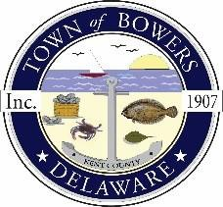

**Town of Bowers**

3357 Main St., Frederica, DE19946

(302)572-9000

Bowersbeach.delaware.gov

**TOWN MEETING**

**AGENDA** Thursday, April 11, 2024

**REGULAR MEETING 7:00 pm**

**Join Zoom Meeting**

<https://us02web.zoom.us/j/82853924270?pwd=VXpOaStnQWNJZTh3bVFDcHV2YzJQZz09>

Meeting ID: 828 5392 4270

Passcode: 811652

**Pledge of Allegiance**

**MINUTES AND REPORTS**

Meeting Minutes Approval for March 2024

Treasurer’s Report Approval for March 2024

**COMMITTEE REPORTS**

Parking Lot

Watermen’s Park

N Bayshore Drainage

Parks and Recreation

Planning Committee

Public Water Committee

Code Enforcement

Board of Adjustments

**OLD BUSINESS**

**Grants and Projects:**

Museum Renovations

Town of Bowers Flood Risk Reduction Feasibility Study

**NEW BUSINESS**

Upcoming Museum Events

**RESIDENT CONCERNS/TOPICS**

**COUNCIL COMMENTS**

All monthly Town working sessions will be held on the Monday before the regular town meeting

starting on Monday, April 8th. In person only at the Annex from 7:00 pm to 8:00 pm

*Reminder: please notify Ada Puzzo or Chris Telles by the first Thursday of every month if you have a concern or topic you would like to address at the next Town Meeting*