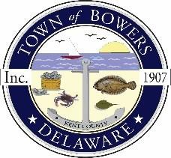
Town of Bowers
3357 Main St., Frederica, DE19946
(302)572-9000
Bowersbeach.delaware.gov

TOWN MEETING
AGENDA
Monday, July 29, 2024
SPECIAL MEETING 8:00 pm
Cancelled

Pledge of Allegiance
NEW BUSINESS

Executive Session

Executive session for “[p]reliminary discussions on site acquisitions for any publicly funded capital improvements, or sales or leases of real property” pertaining to 16 Hubbard Ave., Bowers, Delaware (29 Del. C. § 10004(b)(2))

Public Session

Discussion and possible action to bid on 16 Hubbard Ave., Bowers, Delaware at the Kent County Sheriff Sale to be held July 30, 2024

Reminder: please notify Ada Puzzo or Chris Telles by the first Thursday of every month if you have a concern or topic you would like to address at the next Town Meeting

