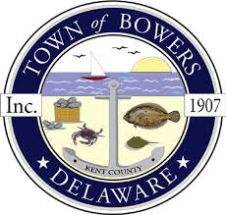

TOWN OF BOWERS
THE TOWN OF BOWERS, NORTH BAYSHORE DRIVE DRAINAGE IMPROVEMENTS

QUESTIONS AND ANSWERS – June 2026

